**Food for Thought**

**Trainer Handbook**

Output type: Output I02-T2

**South West College, Northern Ireland**

**IDAN, Iceland**

**People 1st, United Kingdom**

**St. Angela’s College, Sligo, Republic of Ireland**

**Lycée des métiers de l’hôtellerie et du tourisme Alexandre Dumas, France**

   

May, 2019

|  |  |
| --- | --- |
| Project acronym: | FfT |
| Project name: | Food for Thought |
|  |  |

**Document History**

|  |  |  |  |  |
| --- | --- | --- | --- | --- |
| Versions | Date | Changes | Type of change | Delivered by |
| 1.0 | 14/05/19 | - | - | SAC |
|  |  |  |  |  |
|  |  |  |  |  |
|  |  |  |  |  |

|  |  |
| --- | --- |
| **Document Information** |  |
| Document ID name: | FfT_I02-T2_Trainer Handbook |
| Document title: | FfT Trainer Handbook |
| Output Type: | Intellectual Output I02-T2 |
| Date of Delivery: | 14/05/19 |
| Activity Type: | Document |
| Activity Leader: | SAC |
| Dissemination level: | Output |

**Disclaimer**

The European Commission support for the production of this publication does not constitute an endorsement of the contents which reflects the views only of the authors, and the Commission cannot be held responsible for any use which may be made of the information contained therein.

This document is proprietary of the FfT Project. Project material developed in the context of Project Management & Implementation activities is not allowed to be copied or distributed in any form or by any means, without the prior written agreement of the FfT Project Team.

**Table of contents**

PART ONE 4

Introduction 4

Development of the Learning Outcomes 5

Grouping of learning outcomes into learning units 6

A unit of learning outcomes 6

ECVET principles 6

Methodology for designing learning units 6

Grouping criteria 7

Learning Outcomes Overview 8

Learning Unit 1 Description 9

Learning Unit 2 Description 10

Learning Unit 3 Description 12

Learning Unit 4 Description 13

Learning Unit 5 Description 14

Learning Unit 6 Description 15

Purpose of the Trainer Handbook 17

Learning Resources 18

Overview Document 18

Presentations 18

Podcasts 19

Case studies 19

PART TWO 20

**Delivery Guidelines – Unit 1** 20

Unit Summary: 20

Key Topics: 20

Assessment 21

Assessment 1 21

Assessment 2 21

Assessment 3 21

Unit 1: Introduction to Sustainable Management in Catering Operations 21

**Delivery Guidelines – Unit 2** 22

Unit Summary 22

Key Topics: 23

Assessment 23

Assessment 1 24

Assessment 2 24

**Delivery Guidelines – Unit 3** 25

Unit Summary: 25

Key Topics: 25

Assessment 26

Assessment 1 26

Assessment 2 26

Assessment 3 26

**Delivery Guidelines – Unit 4** 26

Unit Summary: 26

Key Topics: 27

**Delivery Guidelines – Unit 5** 28

Unit Summary: 28

Key Topics: 29

**Delivery Guidelines – Unit 6** 30

Unit Summary: 30

Key Topics: 30

PART THREE 33

Assessment 33

PART FOUR 34

Online Course Delivery – 34

# PART ONE

## Introduction

The key objective of the Erasmus+ Programme is developing initiatives that address VET education training and promote innovation, exchange of experience and knowledge.

This “Food For Thought” (F4T) project brings together 5 European Partners with specific expertise in the provision of catering, food and hospitality training. Through collaboration with national and international industry ambassadors, education providers and government departments, emerging trends and skills requirements have been identified within the sector and this Food for Thought project has been specifically developed to target a key industry requirement. The overall aim of the Food for Thought Programme is to equip future hospitality and catering employees with a sound knowledge of local food systems and sustainable food practices.

Achievement of three innovative outputs are seen as a priority to support educational and behavioral change in valuing local food systems and moving towards long term sustainability; identifying evidence based learning outcomes for the course and development of 6 bespoke learning units, production of Food for Thought curricula and course materials, provision of an open source online toolkit to provide access and enable VET trainers across Europe to independently deliver the innovative curricula and course materials.

The Food for Thought Project involves the following partners:

South West College, Northern Ireland

St Angela’s College Sligo, Republic of Ireland

Lycée des métiers de l’hôtellerie et du tourisme Alexandre Dumas, France

IDAN, Iceland

People 1st, United Kingdom

Collectively the partners recognise the priorities of the EU 2020 “New Skills for New Jobs" by:

• Seeking to anticipate more clearly future skills needs

• Developing better matching between skills and labour market needs

• Bridging the gap between the worlds of education and work

## Development of the Learning Outcomes

The development of the learning outcomes of the FfT program was based on international field and desk research and aimed to examine current and future workplace requirements for modern culinary programs, in terms of local food production and sustainable food practices for culinary leaders. Relevant information was gathered by the project partners through online questionnaires, desk research and analysis of secondary data with the involvement of FfT target groups and a broad range of relevant stakeholders – such as sector employers, VET providers, field experts, students, local food & sustainability ambassadors, trade associations and Governmental bodies. In total there were 571 respondents to the survey gathered from all the participating countries. Desk research was drawn from journal articles, policy documents, research papers, research reports, conference outputs, presentations and case studies.

Learning outcomes were then developed based on the findings of the training needs analysis and primary data collected and analysed in line with the requirements set out by the European Qualification Framework (EQF). The EQF comprises eight reference levels based on ‘learning outcomes’ – defined in terms of knowledge, skills and competences, thus shifting the emphasis from input (type and duration of learning experience) to actual learning, i.e. to what a person is able to do upon the completion of a learning process. Moreover, learning outcomes are used as a basis for credit transfer and accumulation (ECVET, see below) and are specified in the three categories of knowledge, skills and competence.

## Grouping of learning outcomes into learning units

### A unit of learning outcomes

A unit is a component of a qualification consisting of a detailed set of knowledge, skills and competence that can be evaluated, validated and certified. Units enable progressive achievement through transfer and accumulation of learning outcomes defined in knowledge, skills and competence terms. Units of learning outcomes can be specific to a single qualification or common to several qualifications and may also describe so-called additional qualifications which are not part of a formal qualification or curriculum. They are subject to assessment and validation which verify whether the learner has achieved the learning outcomes expected.

### ECVET principles

ECVET stands for European Credit system for Vocational Education and Training. ECVET works hand in hand with the European Qualifications Framework (EQF) to provide greater transparency in European qualifications, promoting the mobility of workers and learners, and facilitating lifelong learning. Successful ECVET implementation requires that qualifications be described in terms of learning outcomes; with learning outcomes brought together in units; and units often accumulated to form the basis of qualifications or awards. Assessment, validation and recognition processes must also be agreed among all those participating and should respect existing national, regional, sectoral or institutional practice. Furthermore, ECVET requires the use of units to facilitate the transfer, recognition and accumulation of assessed learning outcomes of individuals who are aiming to achieve a professional profile. In cases where credit is able to be awarded, a points system might also be considered with points directly attributed to ECVET units and qualifications.

### Methodology for designing learning units

The approach adopted for designing the FfT learning units follows the shift to competence and career-oriented education and training, in alignment with the research and results obtained in the first Intellectual Output (O1) of the project. It breaks down the overall learning outcomes to individual smaller learning outcomes that may be more easily mapped to the needs and realities of both learners and trainers. The process followed, in compliance with the provisions of the project's Application Form, has been to group and sequence learning outcomes logically in learning units, resulting in individual units that learners can select as being most relevant to their needs. At the same time, VET providers and trainers could take a unit from one course and use it with minor adaptation in another course. The FfT learning units design methodology also took into account that corresponding educational resources need to be provided openly for integration in online and face-to-face courses, as well as to be in a MOOC, and avoided tight sequencing and interdependencies between the proposed learning units.

The ECVET recommendation suggests that the description of a unit should include the following information:

* the title of the unit;
* the title of the qualification to which the unit relates;
* the EQF level of the qualification (and, where appropriate,
* the NQF the ECVET points associated with the unit;
* the learning outcomes contained in the unit;
* The procedures and criteria for assessment of these learning outcomes, the validity in time of the unit, where relevant. level);

### Grouping criteria

Grouping criteria, based on European principles - Based on the European principles, a unit of learning outcomes should provide a comprehensive and consistent learning process. The criteria that should and have be taken into consideration when determining the units of learning outcomes for FfT are the following:

* Units of learning outcomes can be completed and assessed, as independently as possible from other units of learning outcomes.
* Units of learning outcomes are structured in such a way that the relevant learning outcomes can be achieved in a specific time interval. Units of learning outcomes should therefore not be too extensive.
* Units of learning outcomes include all necessary learning outcomes in order to cover the objectives of the units.
* Units of learning outcomes are designed to be assessable.

Grouping criteria, based on FfT targets - Based on the specific requirements and objectives of the FfT Project, the partnership also identified that:

* Units of learning outcomes need to be developed to reflect relevant needs within the catering sector, so as to address skills gaps, improve employability and stimulate food entrepreneurism.
* Units of learning outcomes need to reflect the overall aim of the FfT project i.e. to equip future hospitality employees with strengthened knowledge and skills of competence to understand the economic, environmental and social benefits of local food systems and sustainable food practices.
* Units of learning outcomes must target trainee chefs as the main target group for the project, additionally courses will also be aimed at a broader range of stakeholders in the Culinary, Hospitality and Tourism sectors.

The main learning outcomes have been developed to focus on the following areas:

|  |
| --- |
| Understand the meaning of sustainability in a catering operation. |
| Know the benefits of creating a sustainable kitchen. |
| Understand the concept ‘From sea and farm to fork’. |
| Know the benefits of using local ingredients for a catering business. |
| Understand the meaning of food waste in a catering operation |
| The three Rs concept |
| Explain current trends in the hospitality sector. |
| Recognise how current trends and lifestyle choices of the consumer affect sustainability the food production. |
| Recognise the benefits of purchasing in season, locally sourced sustainable produce. |
| Identify seasonal, locally sourced and sustainable dishes across a range of menu types. |
| Understand the features of a food destination. |
| Explain how a business or area can become a food destination. |

## Learning Outcomes Overview

The learning outcomes are grouped into learning units in line with VET principles, each unit addressing a number of specific topics.

## Learning Unit 1 Description

|  |  |
| --- | --- |
| **Title** | **Introduction to Sustainable Management in Catering Operations** |
| **Description** | This learning unit introduces the learner to a holistic overview of sustainability, focusing on the benefits to a modern food production environment.  Sustainability is defined, and then broken down into three key areas in order for the learner to gain an understanding of what it takes for a catering operation to be sustainable. The Three Pillars of Sustainability; societal, environmental and economic are discussed to help the learner to understand how they are interrelated. |
| **Overall Learning Outcome** | Learners should understand the meaning of sustainability in a catering operation. They should know the three main elements of sustainability. Also, learners should know the benefits of creating a sustainable catering operation. |
| **EQF level** | 3 |
| **Duration** | 10 hrs Guided Learning Hours (GLH) |
| **ECVET credits** | TBC |
| **Prerequisites** | General. |
| **Assessment** | Assessment 1: multiple-choice test of 20 questions.  Assessment 2: fill in the blanks test.  Assessment 3: 6 short questions based on the Case Study 1. |
| **Learning Outcome 1** | Understand the meaning of sustainability in a catering operation. |
| **Learning Outcome 2** | Know the benefits of creating a sustainable kitchen |

## Learning Unit 2 Description

|  |  |
| --- | --- |
| **Title** | **Food Chain** |
| **Description** | This learning unit provides the learner with an overview of the Food Chain, focusing on awareness of local production, its origins, quality and the environment.  The Food supply Chain is defined and the concept “From sea and farm to fork” is addressed for the learner to gain an understanding of the food value chain and the benefits of sustainable food production for Catering operations. |
| **Overall Learning Outcome** | Learners should understand the main the elements of the food Supply Chain, know the concept from sea and farm to Fork, be able to describe the key elements of sustainable food production. Also, learners should know the benefits of sustainable food production for Catering operations. |
| **EQF level** | 3 |
| **Duration** | 10 hrs GLH |
| **ECVET credits** | TBC |
| **Prerequisites** | General+ Learning Outcomes of Learning Unit 1, Sustainability in Food Production. |
| **Assessment** | Assessment 1: multiple-choice test of 20 questions.  Assessment 2: 6 short questions based on the Case Studies 1-4. |
| **Learning Outcome 1** | Understand the concept “From sea and farm to fork”. |
| **Learning Outcome 2** | Know the benefits of using local ingredients for a Catering Business. |

## Learning Unit 3 Description

|  |  |
| --- | --- |
| **Title** | * **Waste in food Production** |
| **Description** | This learning unit introduces the learner to the concept of waste reduction, its management and impact.  The learner is first introduced to the definition of Food Waste, next Sustainability is defined, and then the learner will be made familiar with the Rs theory in order to gain a better understanding of how to reduce waste in a catering operation. |
| **Overall Learning Outcome** | Learners should understand the meaning of food waste in catering operations, be familiar with the three R’s: reuse, reduce and recycle, and know the environmental, economic and social benefits of a food waste management policy. |
| **EQF level** | 3 |
| **Duration** | 10 hrs GLH |
| **ECVET credits** | TBC |
| **Prerequisites** | General+ Learning Outcomes of Learning Unit 1, Sustainability in Food Production. |
| **Assessment** | Assessment 1: fill in the blanks test.  Assessment 2: matching exercise.  Assessment 3: devising a commitment charter. |
| **Learning Outcome 1** | Understand the meaning of food waste in a catering operation |
| **Learning Outcome 2** | The 3 Rs concept |

## Learning Unit 4 Description

|  |  |
| --- | --- |
| **Title** | * **Trends and Lifestyles** |
| **Description** | This learning unit will enable the learner to understand how current trends and lifestyle choices affect sustainability in food production.  The learner is introduced to current trends and lifestyle choices and will explore their impact on catering operations. It will also identify actions businesses can adopt to tap into changing consumer values and move towards becoming a sustainable food operation. |
| **Overall Learning Outcome** | Learners should become familiar with current trends in the hospitality sector, develop and understanding of how current consumer trends and lifestyle choices affect sustainability in catering operations. Learners should also identify what measures a catering operation can adopt to respond to changing consumer values. |
| **EQF level** | 3 |
| **Duration** | 10 hrs GLH |
| **ECVET credits** | TBC |
| **Prerequisites** | General+ Learning Outcomes of Learning Unit 1, Sustainability in Food Production. |
| **Assessment** | Assessment 1: True or False exercise.  Assessment 2: investigation exercise.  Assessment 3: group discussion exercise. |
| **Learning Outcome 1** | Explain current trends in the hospitality sector. |
| **Learning Outcome 2** | Recognise how current trends and lifestyle choices of the consumer affect sustainability in food preparation. |

## Learning Unit 5 Description

|  |  |
| --- | --- |
| **Title** | * **Sustainable Sourcing and Procurement for Catering Operations** |
| **Description** | This learning unit enables learners to explore sustainable sourcing and procurement for catering operations.  The learner is introduced to sustainable procurement. Procurement is defined, and explored in relation to the catering industry. Learners are encouraged to discuss the environmental, social and financial benefits which should be considered when deciding on a product to source. They are also guided to plan a menu for an identified region and season which showcase a range of sustainable, locally sourced and seasonal dishes. |
| **Overall Learning Outcome** | Learners should be able to recognise the benefits of purchasing in season, locally sourced sustainable produce. Also, learners should be able to identify seasonal, locally sourced and sustainable dishes across a range of menu types. |
| **EQF level** | 3 |
| **Duration** | 10 hrs GLH |
| **ECVET credits** | TBC |
| **Prerequisites** | General+ Learning Outcomes of Learning Unit 1, Sustainability in Food Production. |
| **Assessment** | Assessment 1: group work.  Assessment 2: group work.  Assessment 3: creation of a menu.  Extension 1: multiple-choice test of 20 questions.  Extension 2: fill in the blanks test. |
| **Learning Outcome 1** | Recognise the benefits of purchasing in season, locally sourced sustainable produce. |
| **Learning Outcome 2** | Identify seasonal, locally sourced and sustainable dishes across a range of menu types. |

## Learning Unit 6 Description

|  |  |
| --- | --- |
| **Title** | * **Food Destinations** |
| **Description** | This learning unit introduces the learner to the new and emerging trend of Food Destinations, and examines how a destination can transform into a food destination.  The learner is introduced to food tourism and the concept of utilising food as a main attraction in destination marketing. A food destination is defined, and examples of food destinations are presented in video clips and case studies. |
| **Overall Learning Outcome** | Learners should understand the features of a food destination. They should understand that a food destination is an integral part of destination marketing and know how an area can become a food destination. |
| **EQF level** | 3 |
| **Duration** | 10 hrs GLH |
| **ECVET credits** | TBC |
| **Prerequisites** | General+ Learning Outcomes of Learning Unit 1, Sustainability in Food Production. |
| **Assessment** | Assessment 1: multiple-choice test of 20 questions.  Assessment 2: fill in the blanks test.  Assessment 3: creation of marketing material exercise. |
| **Learning Outcome 1** | Defining a Food Destination. |
| **Learning Outcome 2** | Explain how a business or area can become a food destination. |

|  |  |
| --- | --- |
| **Title** | **Food For Thought** |
| Description | Trainee chefs, and other members of the Culinary, Hospitality and Tourism sector, who undertake this course will be equipped with all needed skills, knowledge and competence in order to meet current and emerging workplace demands with regard to local food systems and sustainable food practices.  During the course, learners will learn:   * Basic facts and principles of sustainability and management for improving Catering Operations. * The benefits of sourcing local sustainable produce. * Procedures to prevent waste in food production * Integrating Trends and Lifestyle Choices in business * Sustainable Sourcing and Procurement for Catering Operations * Establishing and Marketing a Food Destination |
| EQF level | TBC |
| Duration | 60 GLT |
| ECVET credits | TBC |

## Purpose of the Trainer Handbook

The Trainer Handbook (TH) is a guide to help the instructor to deliver the digital and environmental skills course for facility managers in buildings. The TH will summarise the methodology to be used by the instructor for each unit. The intention of the handbook is not to be over prescriptive so that there is flexibility for the trainers to employ their own pedagogical approaches and concentrate on areas they feel need greater attention. The objective is to achieve the learning outcomes outlined for the course.

The Trainer Handbook will outline the objectives for each unit, clearly demonstrate what is required of the trainers, listing resources required. The TH provides directions for the students as how to complete the activities and direction to the trainers regarding assessment. It will provide a pool of assessments, exercises and various activities to be completed by the students.

To better facilitate training and ensure completion of its goals, the project’s curriculum has been organised in six thematically consistent Units, which have been further broken up into a number of activities designed to engage students in learning. Activities include a PowerPoint presentation, video presentation, demonstrations, FAQs, assessments, discussion and exercises that can be either individual or group work. These will be discussed in greater detail below. Activities may be assessed for certification purposes.

It should be noted that both the organisational structure and the exact content of the course should not be considered invariable and thus become restrictive and unwieldy; in fact Trainers are encouraged to tailor the materials‘ forms and content to the perceived specific needs of their audience/trainees to the extent that this is possible to ensure that the core of the project’s curriculum remains intact and can thus be accurately transferred to the trainees.

Trainers need to ensure that appropriate links are made between theory and practical application and that the knowledge base is applied to the sector. This is

ensured by development of relevant and up-to-date teaching materials that allow learners to apply their learning to actual events and activity within the sector.

## Learning Resources

The Development of training resources and assessment materials are based on the FfT units of learning outcomes. The training materials have been created to support proficiency of Trainee chefs, and other members of the Culinary, Hospitality and Tourism sector in local food systems and sustainable food practices such as slide presentations, notes, case studies, and audio-visual aids. Accordingly, assessment tools have been created to provide learners with the opportunity to monitor their progress and evaluate the extent to which they have attained the desirable knowledge and skills. Multiple choice questions and frequently asked questions, practical exercises and application scenarios will comprise the assessment material and tools.

## Overview Document

Each Learning unit has an introductory overview document, this provides a brief note on the content and the expected learning outcomes.

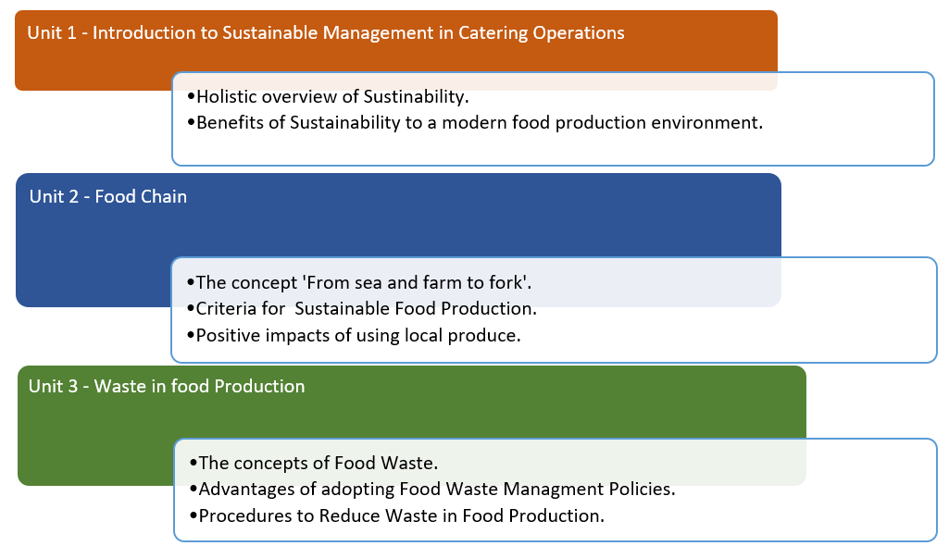

## Presentations

The main aim of the presentations is to assist the trainer with the delivery of the of the FfT learning materials. This will follow the format of the learning outcomes and also corresponds which the Units. The course is constructed so that there is a combination of PowerPoint presentations, videos, podcasts, case studies and frequently asked questions. For each Unit, a summary will be presented on a PowerPoint slide, which will provide an overview of the content within that unit.

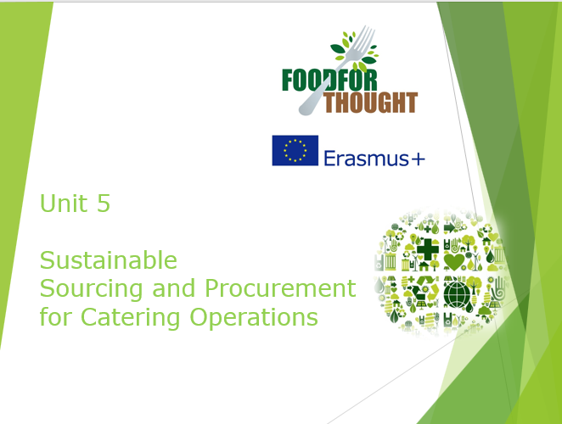

## Podcasts

There will be a series of podcasts integrated into the MOOC platform which will correspond with each learning unit focusing on keys points per learning unit.

## Case studies

The main aim of the cases is to facilitate the trainer with integration of the FfT learning materials with real life examples of best practice. It also serves as the model for some live videos and exercise work. Some case studies are linked to unit assessment others while others are provided for additional learning resources.

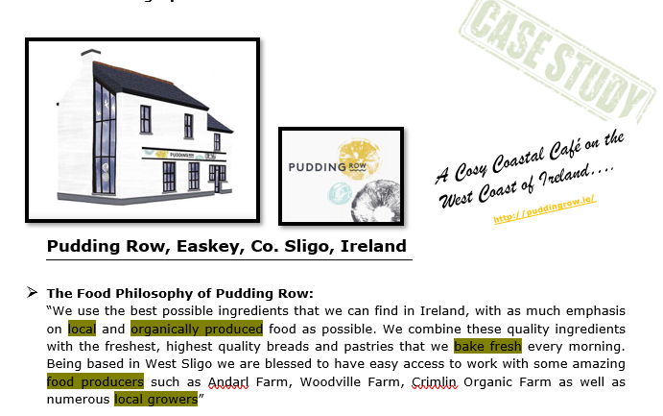 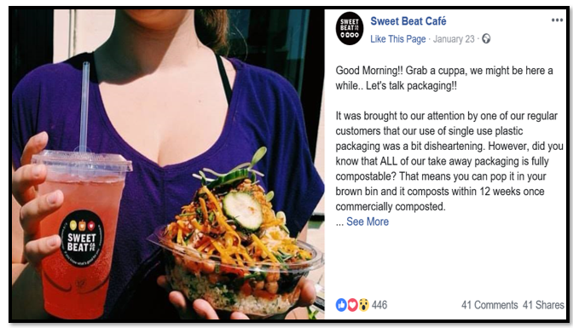

# PART TWO

## **Delivery Guidelines – Unit 1**

### Unit Summary:

On successful completion of this unit students should;

1. Understand the meaning of sustainability in a catering operation.
2. Know the three main elements of sustainability.
3. Know the benefits of sustainability in a catering operation.

This learning unit introduces the learner to sustainability. Sustainability is defined, and then broken down into three key areas in order for the learner to gain an understanding of what it takes for a catering operation to be sustainable.

The Three Pillars of Sustainability; societal, environmental and economic are discussed to help the learner to understand how they are interrelated.

### Key Topics:

* Defining sustainability
* The Three Pillars of Sustainability
* The Triple Bottom Line of Sustainability
* The consumer demand for sustainably sourced food
* The Benefits of sustainability to a catering business

|  |  |
| --- | --- |
| **Materials and teaching resources – Unit 1** | |
| **Type of Resource** | **Notes** |
| **Power Point Presentation 1:**  Introduction to Sustainabile Management in Catering Operations | Main topics covered in the presentation:   * Defining Sustainability; * The Three Pillars of Sustainability; * Societal Pillar; * Environmental Pillar; * Economic Pillar; * Consumer awareness; * The Benefits of sustainability to a catering business.   The presentation is supplemented with two video clips:   * Video Unit 1a. Triple Bottom Line / 3 Pillars of Sustainability Explained; * Video Unit 1b. Sustainable Catering. |
| **Case Studies:**   1. [Monty's Lounge Restaurant - Local, sustainable, ethical business](https://microsites.bournemouth.ac.uk/destinationfeelgood/files/2015/04/Case-Study-Monty%E2%80%99s-Lounge-Restaurant.pdf) 2. [Poco Tapas Bar, Bristol](https://thesra.org/members/poco/) 3. [Azurmendi, Spain](http://www.climatefriendlyfood.org.uk/) 4. [Contini, Edinburgh](Whitehttps://www.carbontrust.com/media/5892/cts289-whitbread.pdf) | Case Study 1  [Monty's Lounge Restaurant - Local, sustainable, ethical business](https://www.foodethicscouncil.org/uploads/publications/Catering%20for%20Sustainability_Full_Report(1).pdf)  Case Study 2  [Poco Tapas Bar, Bristol](http://www.failteireland.ie/FailteIreland/media/WebsiteStructure/Documents/Publications/FI-Food-Strategy-Document.pdf)  Case Study 3  [Azurmendi, Spain](https://azurmendi.restaurant/en/sustainable-restaurant/)  Case Study 4  [Contini, Edinburgh](https://www.contini.com/about/sustainability) |

# Assessment

|  |  |
| --- | --- |
| **Learning Outcomes** | **Assessment Criteria** |
| 1. Understand the Meaning of sustainability in a catering operation | 1.1 Explain the meaning of sustainability in a catering operation.  1.2 Describe the key factors of sustainability in a catering operation |
| 1. Know the benefits of creating a sustainable catering operation | 2.1 Explain the positive impacts of a catering operation adapting sustainable practices |

The assessments for Unit 1 cover both the learning outcomes and the assessment criteria listed above. The assessments overlap with some covering more than one criterion.

## Assessment 1

Assessment 1 is a multiple-choice test where the learner must choose one answer for each of the 20 questions. This addresses assessment criteria 1.1 and 1.2.

## Assessment 2

Assessment 2 is a fill in the blanks test where the learner must choose a word from a selection at the top of the page to fill in any blanks in order to make sense of the paragraph. This addresses assessment criteria 1.1 and 1.2.

## Assessment 3

Assessment 3 is a list of 6 short questions to be answered based on the Case Study 1. This addresses criteria 1.2 and 2.1.

# Unit 1: Introduction to Sustainable Management in Catering Operations

***The following information relates to Unit 1 PowerPoint and general support material for Unit 1.***

Useful Links

* The Sustainable Restaurant’s Association - [https://awards.thesra.org/](http://www.soilassociation.org/)
* [https://openforbusiness.opentable.com/tips/12-ways-to-make-your-restaurant-more-sustainable/](http://www.sustainablefoodcities.org/)

Sources of Information

* Azurmendi, 2018. *Azurmendi wins the most sustainable restaurant award by The World’s 50 Best Restaurants.* [Online] Available at: [https://azurmendi.restaurant/en/azurmendi-wins-sustainable-restaurant-award-worlds-50-best-restaurants/](https://www.visitbritain.org/sites/default/files/vb-corporate/Documents-Library/documents/England-documents/margaret_river_case_study_21_nov_2016_-_final_approved_by_case_study_contact.pdf)   
  [Accessed 6 December 2018].
* Bournemouth University, 2015. *Case Study Monty's Lounge Restaurant.* [Online] Available at: <https://microsites.bournemouth.ac.uk/destinationfeelgood/files/2015/04/Case-Study-Monty%E2%80%99s-Lounge-Restaurant.pdf>   
  [Accessed 12 December 2018].
* Contini, V. &. C., 2018. *Sustaibability.* [Online]   
  Available at:   
  <https://www.contini.com/about/sustainability>   
  [Accessed 10 December 2018].
* Open Table, 2015. 12 Ways to Make Your Restaurant More Sustainable. [Online] Available at: [https://openforbusiness.opentable.com/tips/12-ways-to-make-your-restaurant-more-sustainable/](https://azurmendi.restaurant/en/sustainable-restaurant/)   
  [Accessed 10 December 2018].
* Sustainable Restaurants Association, 2018. Poco Tapas Bar, Bristol. [Online] Available at: [https://awards.thesra.org/awards/business-of-the-year/](http://cf.cdn.unwto.org/sites/all/files/pdf/gastronomy_report_web.pdf)   
  [Accessed 5 December 2018].
* YouTube, 2015. Triple Bottom Line/ 3 Pillars of Sustainability 2. [Online] Available at: <https://www.youtube.com/watch?v=GsTPbnV8nE0>   
  [Accessed 21 December 2018].
* YouTube, 2017. Sustainable Catering in 2 mins. [Online] Available at: <https://www.youtube.com/watch?v=nb_36ouU2xE&t=43s>   
  [Accessed 21 December 2018].

## **Delivery Guidelines – Unit 2**

### Unit Summary

On successful completion of this unit students should;

1. Be able to define the main elements of the Food Supply Chain,
2. Know the concept “From sea and farm to fork”,
3. Be able to describe the key elements of sustainable food production,
4. Know the benefits of sustainable food production for Catering operation.

In this unit the learner is introduced to the Food supply Chain and the benefits of sustainable food production for Catering operation. The Food supply Chain is defined and the concept “From sea and farm to fork” is addressed for the learner to gain an understanding of the food value chain and the benefits of sustainable food production.

### Key Topics:

* Defining the Food Supply Cain;
* Defining the concept “From sea and farm to fork”;
* Addressing the main elements of Sustainable Food Production;
* The Benefits of using Local Food in Operations.

|  |  |
| --- | --- |
| **Materials and teaching resources – Unit 2** | |
| **Type of Resource** | **Notes** |
| **Power Point Presentation 2:**  Food Supply Chain and Sustainability, from sea and farm to fork | Main topics covered in the presentation:   * Defining the Food Supply Chain * The movement “From sea and farm to fork” * Main elements of Sustainable Food production * The Benefits of local food to a catering business   The presentation is supplemented with three video clips:   * Video Unit 2a Food Supply Chain. * Video Unit 2b Organic Farming |
| **Case Studies:**   1. Sustainability in the Kitchen – Food & Drink 2. How to Go Green at Your Restaurant 3. Sustainable Food Production 4. Sustainable Food | **Hyper-links:**   1. <http://www.greenhotelier.org/our-themes/community-communication-engagement/sustainability-in-the-kitchen-food-drink/> 2. [https://www.thebalancesmb.com/how-to-go-green-at-your-restaurant-2888656](https://azurmendi.restaurant/en/azurmendi-wins-sustainable-restaurant-award-worlds-50-best-restaurants/) 3. [https://www.unenvironment.org/regions/asia-and-pacific/regional-initiatives/supporting-resource-efficiency/sustainable-food](http://www.foodforthoughteu.com) 4. [http://ec.europa.eu/environment/eussd/food.htm](https://microsites.bournemouth.ac.uk/destinationfeelgood/files/2015/04/Case-Study-Monty’s-Lounge-Restaurant.pdf) |

# Assessment

|  |  |
| --- | --- |
| **Learning Outcomes** | **Assessment Criteria** |
| 1. Understand the Food Supply Chain in context with sustainable catering operation. 2. Know the concept “From sea and farm to fork”. | * 1. Describe the main elements   of Sustainable Food   Production.   * 1. Explain the meaning of the concept from sea and farm to fork. |
| 1. Know the benefits of using Local food in Catering Operations. | 3.1 Explain the positive impacts   of a catering operation of   using Local food. |

The assessments for Unit 2 cover both the learning outcomes and the assessment criteria listed above. The assessments overlap with some covering more than one criterion.

## Assessment 1

Assessment 1 is a multiple-choice test where the learner must choose one answer for each of the 20 questions. This addresses assessment criteria 1.1 and 1.2.

## Assessment 2

Assessment 2 is a list of 6 questions to be answered based on Case study 1. This addresses assessment criteria 2.1.

***The following information relates to Unit 2 PowerPoint and general support material for Unit 1.***

* Catering for Sustainability <https://www.foodethicscouncil.org/uploads/publications/Catering%20for%20Sustainability_Full_Report(1).pdf>
* Organic Food – Definition <https://en.wikipedia.org/wiki/Organic_food>
* UN Sustainable Developmental Goals   
  [https://www.un.org/sustainabledevelopment/sustainable-development-goals/](https://www.youtube.com/watch) and   
  [https://www.un.org/sustainabledevelopment/takeaction/](https://awards.thesra.org/)
* [https://www.youtube.com/watch?v=pgNLonYOc9s&t=28s](https://openforbusiness.opentable.com/tips/12-ways-to-make-your-restaurant-more-sustainable/?v=pgNLonYOc9s&t=28s)
* [Food Treasures – example](https://thesra.org/members/poco/)
* [https://mataraudur.is/vizkubrunnur/myndbond/#videos-3](https://mataraudur.is/vizkubrunnur/myndbond/)
* [https://www.youtube.com/watch?v=jKKztahx8aI](https://www.un.org/sustainabledevelopment/sustainable-development-goals/?v=jKKztahx8aI)
* Definition of a Sustainable Food System  
  [https://www.crcresearch.org/sites/default/files/u641/definition_of_a_sustainable_food_system.pdf](http://cf.cdn.unwto.org/sites/all/files/pdf/gastronomy_report_web.pdf)

## **Delivery Guidelines – Unit 3**

### Unit Summary:

On successful completion of this unit students should;

1. Understand the meaning of food waste in a catering operation,
2. Be familiar with the three R’s : reuse, reduce and recycle,
3. Know the environmental, economic and social benefits of a food waste management policy.

In this unit the learner is introduced to food waste. First, food waste is defined, then Sustainability is defined, and then the learner will be made familiar with the Rs theory in order to gain a better understanding of how to reduce waste in a catering operation.

### Key Topics:

* Defining food waste;
* The Three Rs theory;
* The environmental, economic and social benefits of a waste management policy;
* The benefits of food waste reduction to a catering business;

|  |  |
| --- | --- |
| **Materials and teaching resources – Unit 3** | |
| **Type of Resource** | **Notes** |
| **Power Point Presentation 1:**  Food Waste | Main topics covered in the presentation:   * The Three Rs theory; * The environmental, economic and social benefits of a waste management policy; * The benefits of food waste reduction to a catering business; * A commitment charter; * Consumer and vocational awareness.   The presentation is supplemented with one video clip:   * Video Unit 3 : Food Wastage Footprint |
| **Case Studies:**  Case Study 1 - How to Go Green at Your Restaurant  Case Study 2 Sustainability in practice example | **Hyper-links:**  https://www.tropmad.com  https://www.restaurant-les-chauvins.fr |

# Assessment

|  |  |
| --- | --- |
| **Learning Outcomes** | **Assessment Criteria** |
| 1. Identify ways in which reducing food waste has a positive impact | * 1. Define the concepts of food waste   2. Describe the positive impacts of adopting food waste management policies. |
| 1. Understand how to prevent and reduce waste in a food production area | * 1. Illustrate, using examples, procedures to reduce waste in food production. |

The assessments for Unit 3 cover both the learning outcomes and the assessment criteria listed above.

## Assessment 1

Assessment 1 is a fill in the blanks exercise. This addresses assessment criteria 1.1

## Assessment 2

Assessment 2 is a matching exercise. This addresses assessment criteria 1.2.

## Assessment 3

Assessment 3 is a commitment charter where the learner must write a procedure to promote a catering business. This addresses criteria 1.2 and 2.1.

## **Delivery Guidelines – Unit 4**

### Unit Summary:

On successful completion of this unit students should;

* Know current trends in the hospitality sector
* Understand how current trends and lifestyle choices of the consumer affect sustainability in catering operations
* Identify what measures a catering operation can adopt to respond to changing consumer values.

In this unit the learner is introduced to current trends and lifestyle choices and will explore their impact on catering operations. It will also identify actions businesses can adopt to tap into changing consumer values and move towards becoming a sustainable food operation.

### Key Topics:

* Why important?
* Current trends and lifestyle choices
* How can businesses respond to shifting consumer values

|  |  |
| --- | --- |
| **Materials and teaching resources – Unit 4** | |
| **Type of Resource** | **Notes** |
| **Power Point Presentation 4:**  Trends and Lifestyles | Main topics covered in the presentation:   * Why important? * Current trends and lifestyle choices * How can businesses respond to changing consumer values? |
| **Hyperlinked Case Studies:**   1. [**Made in Belfast**](https://awards.thesra.org/awards/business-of-the-year/)   The Company’s main priority is food, which has to be high quality, local where possible and ethically and environmentally sourced.   1. [**River Cottage**](https://openforbusiness.opentable.com/tips/12-ways-to-make-your-restaurant-more-sustainable/)   Everything from the materials sourced to the systems used, strives to have minimal impact on the environment.   1. [**Fish City**](https://fish-city.com/)   The first fish and chip shop in Ireland to achieve Marine Stewardship Council certification. They train all staff on sustainability issues and run a schools project to deliver sustainability messages to local children.   1. [**Forage Restaurant**](https://people1st-my.sharepoint.com/personal/rmckee_people1st_co_uk/Documents/Projects/2017/Food%20for%20Thought/IO2/Forage%20Restaurant)   They connect diners to local fishers, foragers and farmers. They work with local suppliers, adhere to strict sustainable purchasing policies, and are a 100% zero waste establishment.   1. [**Whitbread**](https://www.thebalancesmb.com/how-to-go-green-at-your-restaurant-2888656)   A case study from the Carbon Trust on how Whitbread are driving sustainability in their operations.   1. [**LEON & Ikea Food**](https://www.unenvironment.org/regions/asia-and-pacific/regional-initiatives/supporting-resource-efficiency/sustainable-food)   Case studies for LEON and Ikea Food and sustainable diets in their operations. | |

**Assessment**

|  |  |
| --- | --- |
| **Learning Outcomes** | **Assessment Criteria** |
| 1. Explain current trends in the hospitality sector | * 1. Describe one current trend in the hospitality sector   2. Describe what is meant by the term lifestyle choice |
| 1. Recognise how current trends and lifestyle choices of the consumer affect sustainability in catering operations | 2.1 Explain one action a catering operation can take to adapt to shifting consumer values and be a sustainable food operation. |

The assessments for Unit 4 cover both the learning outcomes and the assessment criteria listed above. The assessments overlap with some covering more than one criterion.

**Assessment 1**

Assessment 1 is a True or False statement test where the learner must select a True or False answer for each statement. This addresses assessment criteria 1.1, 1.2.

**Assessment 2**

Assessment 2 is a creative assessment where the learner must investigate and provide evidence of trends manifesting in the marketplace and discuss their findings. This also addresses assessment criteria 1.1 and 2.1.

**Assessment 3**

Assessment 3 is a group work exercise where the learners should identify and explain three actions a small catering operation can adopt to respond to changing consumer values and be a sustainable food operation. This addresses assessment criteria 2.1.

|  |  |
| --- | --- |
| **Useful resources** |  |
| **Item** | **Format** |
| Sustainweb | [www.sustainweb.org](http://cf.cdn.unwto.org/sites/all/files/pdf/gastronomy_report_web.pdf) |
| FairTrade | [www.fairtrade.org.uk](http://www.fairtrade.org.uk/) |
| MSC-Marine Stewardship Council | [www.msc.org](http://www.msc.org/) |
| Soil Association | [www.soilassociation.org](https://mataraudur.is/vizkubrunnur/myndbond/) |
| Sustainable Food Cities | [www.sustainablefoodcities.org](https://www.un.org/sustainabledevelopment/takeaction/) |
| Low Carbon Farming | [www.climatefriendlyfood.org.uk](http://ec.europa.eu/environment/eussd/food.htm) |
| Sustainable Food Trust | [www.sustainablefoodtrust.org](http://www.sustainablefoodtrust.org/) |

## 

## **Delivery Guidelines – Unit 5**

### Unit Summary:

On successful completion of this unit students should;

1. Recognise the benefits of purchasing in season, locally sourced sustainable produce.
2. Identify seasonal, locally sourced and sustainable dishes across a range of menu types.

This learning unit introduces the learner to sustainable procurement. Procurement is defined, and explored in relation to the catering industry. Learners are encouraged to discuss the environmental, social and financial benefits which should be considered when deciding on a product to source. They are also guided to plan a menu for an identified region and season which showcase a range of sustainable, locally sourced and seasonal dishes.

### Key Topics:

* Sustainable Procurement;
* The benefits of sustainable procurement to people, planet and profit;
* Implementing sustainable procurement when sourcing food;
* Planning a sustainable menu.

|  |  |
| --- | --- |
| **Materials and teaching resources – Unit 5** | |
| **Type of Resource** | **Notes** |
| **Power Point Presentation 5:**  Sustainbale Sourcing and Procurement for Catering Operations | Main topics covered in the presentation:   * Applying Procurement to Catering Operations; * Defining Sustainable Procurement; * Justifying the need for Sustainable Procurement within Catering Operations; * Implementing Sustainable Procurement when Sourcing Food Produce; * Planning a menu to promote Sustainable Procurement. |
| **Case Studies:**   1. Sustainable Procurement in Action at Pudding Row Cafe, Co. Sligo, Ireland. 2. Promoting environmental sustainability at Sweet Beat Café, Co. Sligo, Ireland. 3. Sligo Oyster Experience profiling the quality and variety of Irish Sea produce. | * Food philosphy; * Sustainable packaging in catering businesses; * The use of locally sourced produce; * Promotion of organic, free range and local produce; * The use of plant based produce; * The promotion of local sea-produce. |
| **PodCasts:**   1. Mr. Kelly, Proprietor of The Enchanted Kitchen, Mullinavat, Co. Kilkenny 2. Ms. Kelly, Front of House at The Enchanted Kitchen | * “Buying Local”; * “Waste Management”. |

**Assessment**

|  |  |
| --- | --- |
| **Learning Outcomes** | **Assessment Criteria** |
| 1. Recognise the benefits of purchasing in season, locally sourced sustainable produce. | 1.1 Discuss the environmental, social and financial benefits which should be considered when deciding on a product to source. |
| 1. Identify seasonal, locally sourced and sustainable dishes across a range of menu types. | 1. Plan a menu for an identified region and season which showcase a range of sustainable, locally sourced and seasonal dishes. |

The assessments for Unit 5 cover both the learning outcomes and the assessment criteria listed above. The assessments may overlap with some covering more than one criterion.

**Assessment 1**

Assessment 1 is an individual or paired exercise where learners under the appropriate headings provided, list the benefits that should be considered when deciding to Source Sustainable Produce. This addresses assessment criteria 1.1.

**Assessment 2**

Assessment 2 is an individual menu planning exercise where the learner must select a region and season of their choice. The learner should then design a suitable sustainable 3 course menu that promotes the use of local produce. This addresses assessment criteria 2.1.

## **Delivery Guidelines – Unit 6**

### Unit Summary:

On successful completion of this unit students should;

1. Understand the features of a food destination.
2. Understand that a food destination is an integral part of destination marketing.
3. Know how an area can become a food destination.

In this unit the learner is introduced to food tourism and the concept of utilising food as a main attraction in destination marketing. A food destination is defined, and examples of food destinations are presented in video clips and case studies.

### Key Topics:

* Defining a food destination
* How a place can become a food destination
* Meeting the needs of your target market with separate segments identified.
* Activities and products/services to make an area a food destination
* How to market a food destination

|  |  |
| --- | --- |
| **Materials and teaching resources – Unit 6** | |
| **Type of Resource** | **Notes** |
| **Power Point Presentation 6:**  Food Destinations | Main topics covered in the presentation:   * What is a food destination? * Other common terminology * How a place can become a food destination * Examples of food destinations * Target markets and their characteristics * Food and drink experience themes * Examples of food destination activities, products and services * Marketing a food destination or experience   The presentation is supplemented with three video clips:   * Video Unit 6a: Food Tourism Explained * Video Unit 6b: Food destination - Northern Ireland * Video Unit 6c: Food destination – Emilia Romagna region in Italy |
| **Case Studies:**  Case Study 1 – Kilkenny, Ireland  [Kilkenny - Restaurant Association of Ireland's "Foodie Destination" 2018](http://www.rai.ie/kilkenny-foodie-destination-2018/)  Case Study 2  [Margaret River - Food Destination Case Study](https://www.youtube.com/watch) | |

**Assessment**

|  |  |
| --- | --- |
| **Learning Outcomes** | **Assessment Criteria** |
| 1. Understand the features of a food destination | * 1. Using examples describe what is meant by a food destination |
| 1. Explain how a business or area can become a food destination | * 1. Describe the activities that need to take place to become a food destination   2. Create marketing material to become a food destination of your choice |

The assessments for Unit 6 cover both the learning outcomes and the assessment criteria listed above. The assessments overlap with some covering more than one criterion.

**Assessment 1**

Assessment 1 is a multiple-choice test where the learner must choose one answer for each of the 20 questions. This addresses assessment criteria 1.1 and 2.1.

**Assessment 2**

Assessment 2 is a fill in the blanks test where the learner must choose a word from a selection at the top of the page to fill in any blanks to make sense of the paragraph. This also addresses assessment criteria 1.1 and 2.1.

**Assessment 3**

Assessment 3 is a creative assessment whereby learners show that they can create marketing material. This addresses assessment criteria 2.2.

***The following information is provided as general support material for Unit 6.***

Useful Links:

* [Second](https://www.crcresearch.org/sites/default/files/u641/definition_of_a_sustainable_food_system.pdf) [Global Report on Gastronomy](http://madeinbelfastni.com/) [Tourism](http://www.rivercottage.net/sustainability)
* [Food](http://www.failteireland.ie/FailteIreland/media/WebsiteStructure/Documents/Publications/FI-Food-Strategy-Document.pdf) [and Drink Strategy 2018-2023](http://www.sustainweb.org/)

PART THREE

## Assessment

An assessment measures whether the participants have achieved the learning outcomes of the training or not. Testing and assessment starts with knowing exactly what you want to measure. This is related to the learning objectives of the programme. The learning objectives connect the instructional content (what you would like to test) with the assessment (how you would like to test).

For the FfT programme a range of individual, pair and group assessment exercises have been developed.

For the FfT programme the following assessment materials have been developed:

* **Multiple Choice Questions,**
* **Fill in the Blanks Exercises,**
* **Written Tests,**
* **Matching Exercises,**
* **True / False Tests,**
* **Creative Exercises,**
* **Menu Planning,**

Sample answers have been provided for all assessment exercises as support materials.

# 

# PART FOUR

## Online Toolkit

The online toolkit containing all course materials are found on the projects website at [www.foodforthoughteu.com](https://www.contini.com/about/sustainability). This section informs the user how to navigate through the online toolkit to deliver the course.

Homepage

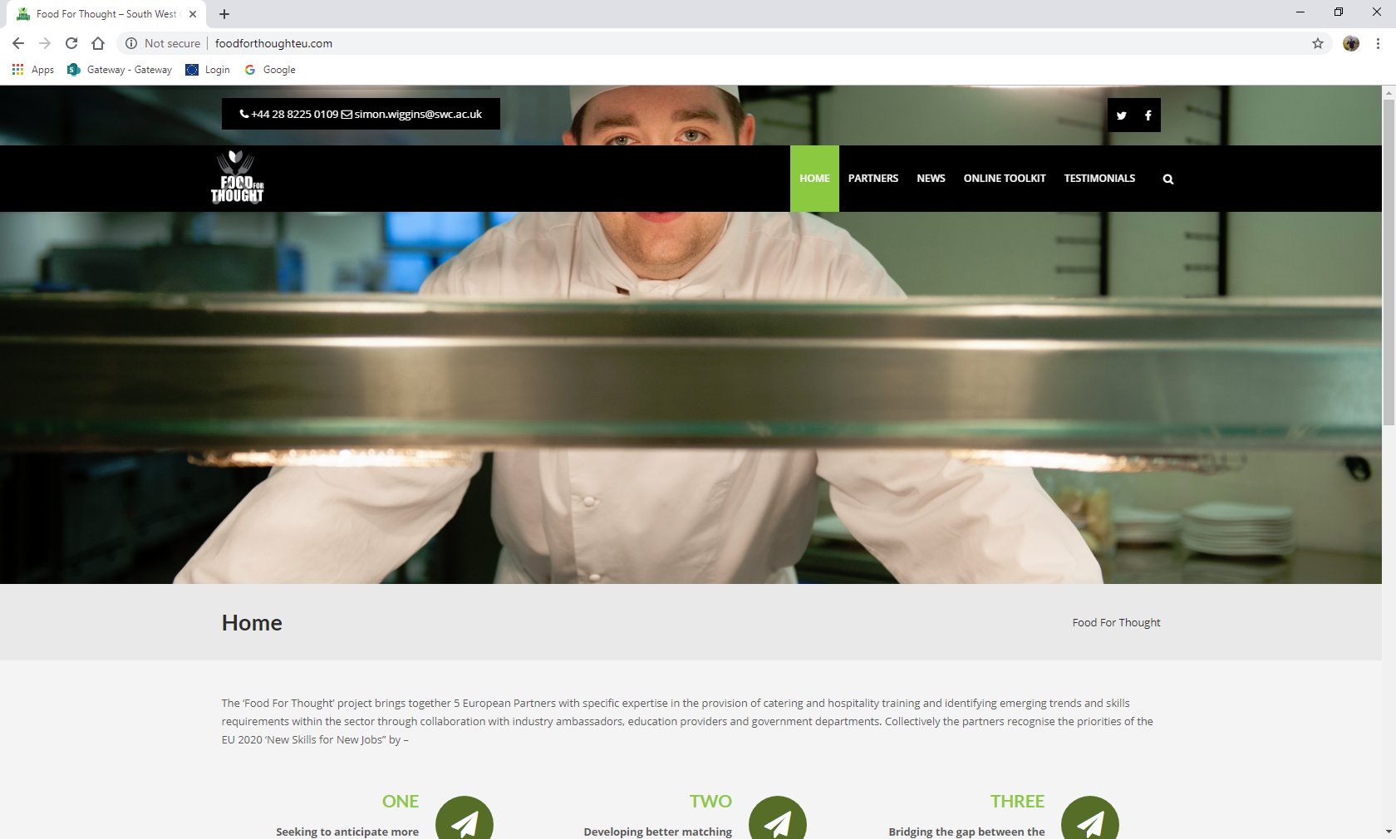

Above image is the ‘Food For Thought’ website homepage that is displayed for users when accessing the projects website or online toolkit. The screen displays various options in the ‘tab’ bar for example sections on ‘Partners’ containing details on project partners and their organisations, ‘News’ with up-to-date information on recent project meetings and also displayed here is the ‘Online Toolkit’ option allowing users to access the course materials.

Online Toolkit

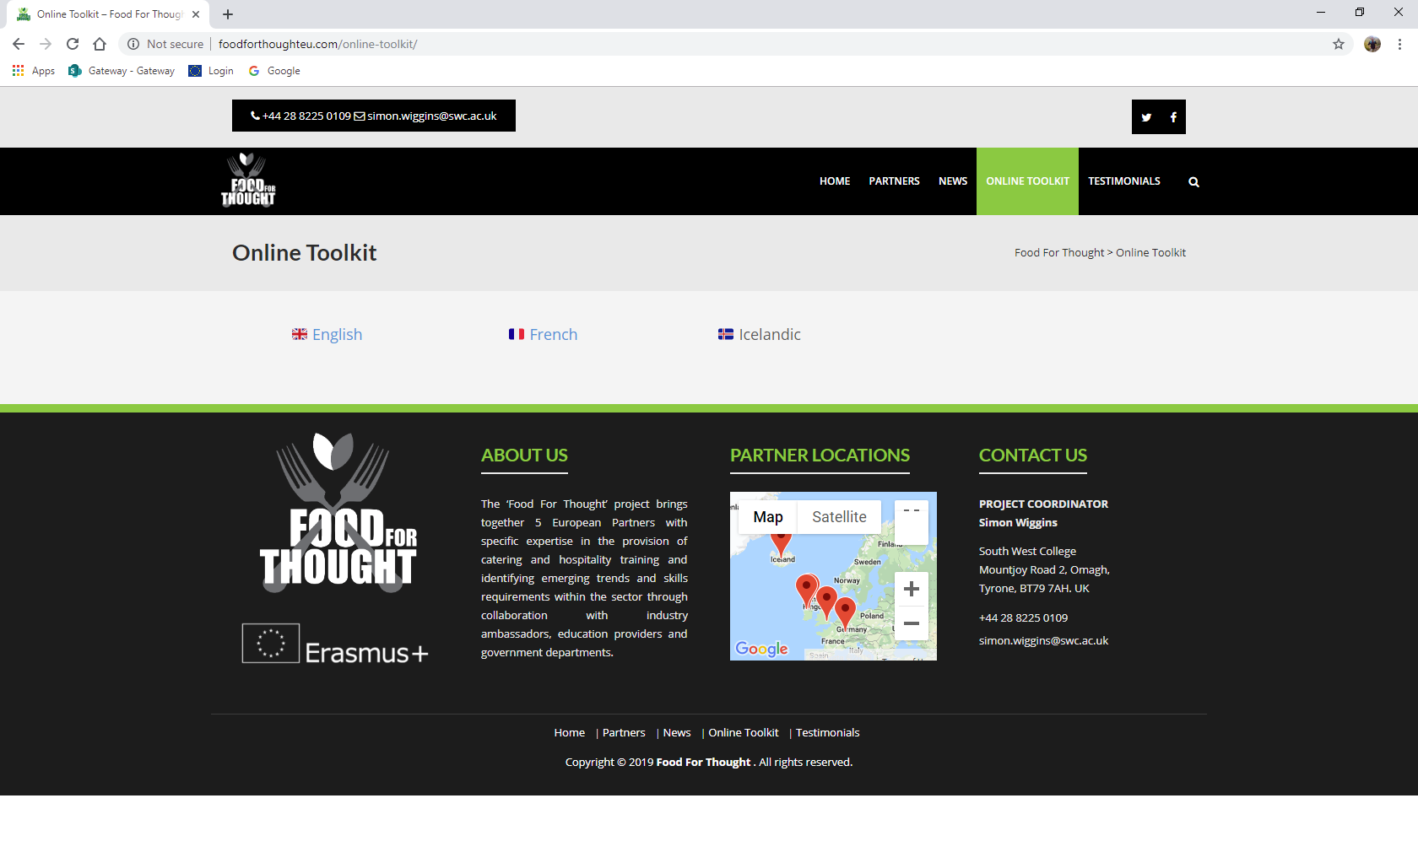

After selecting ‘Online Toolkit’ the website will display the above image, asking the user to select which language they would like to view the course material in. Language options are currently English, French and Icelandic. For the purpose of this trainer manual, we will use English as our example.

Resources – Unit Selection

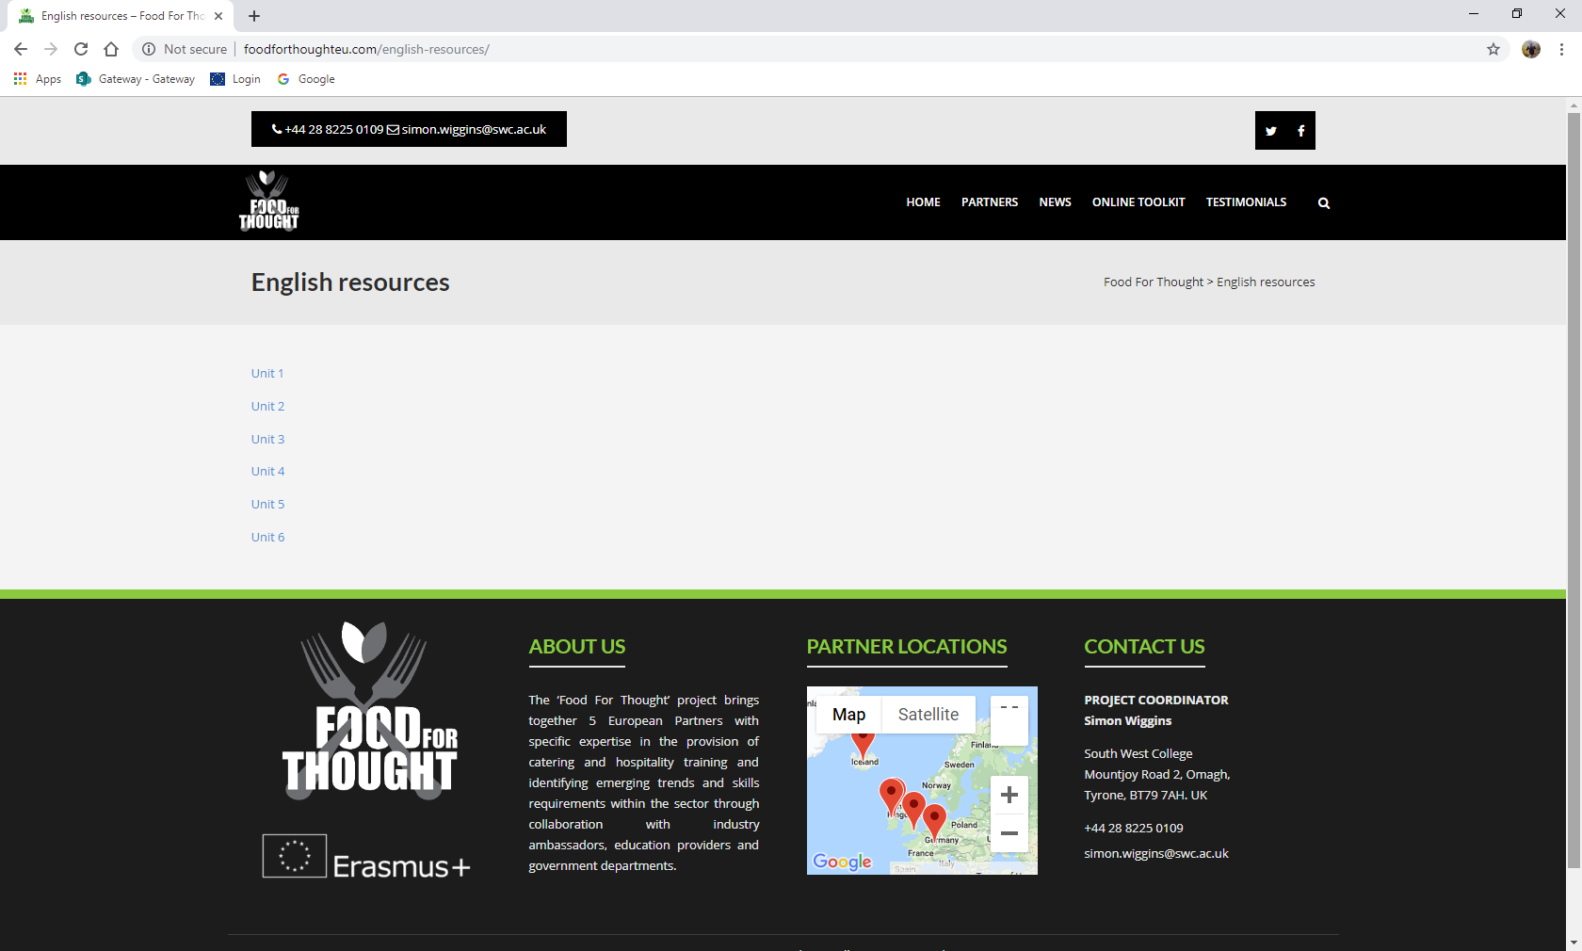

The image on the previous page pictures all six units and their titles listed. The user can select their chosen unit to view its course material. This allows the user to easily separate materials for each unit and teach the course in unit order.

Resources – Unit Material

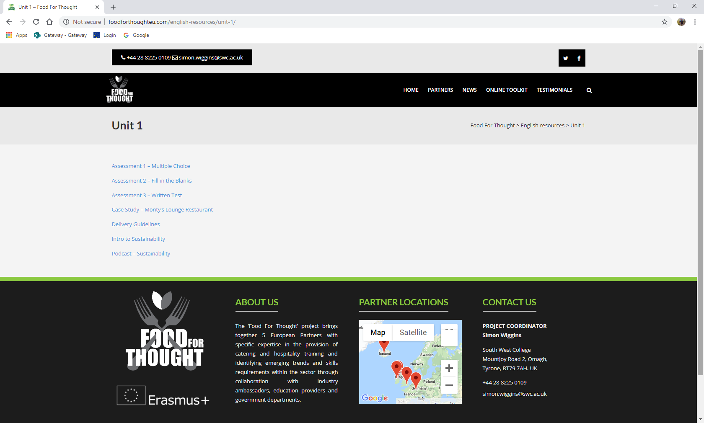

Using Unit 1 as an example, the unit material page lists all the documents associated with this unit. Typically, every unit contains a PowerPoint presentation, assessments and delivery guideline document. Some units also include case studies and podcasts linked to the unit subject. The user can select the material they wish to view which leads onto the next screen.

Resources – View Online, Download or Print Material

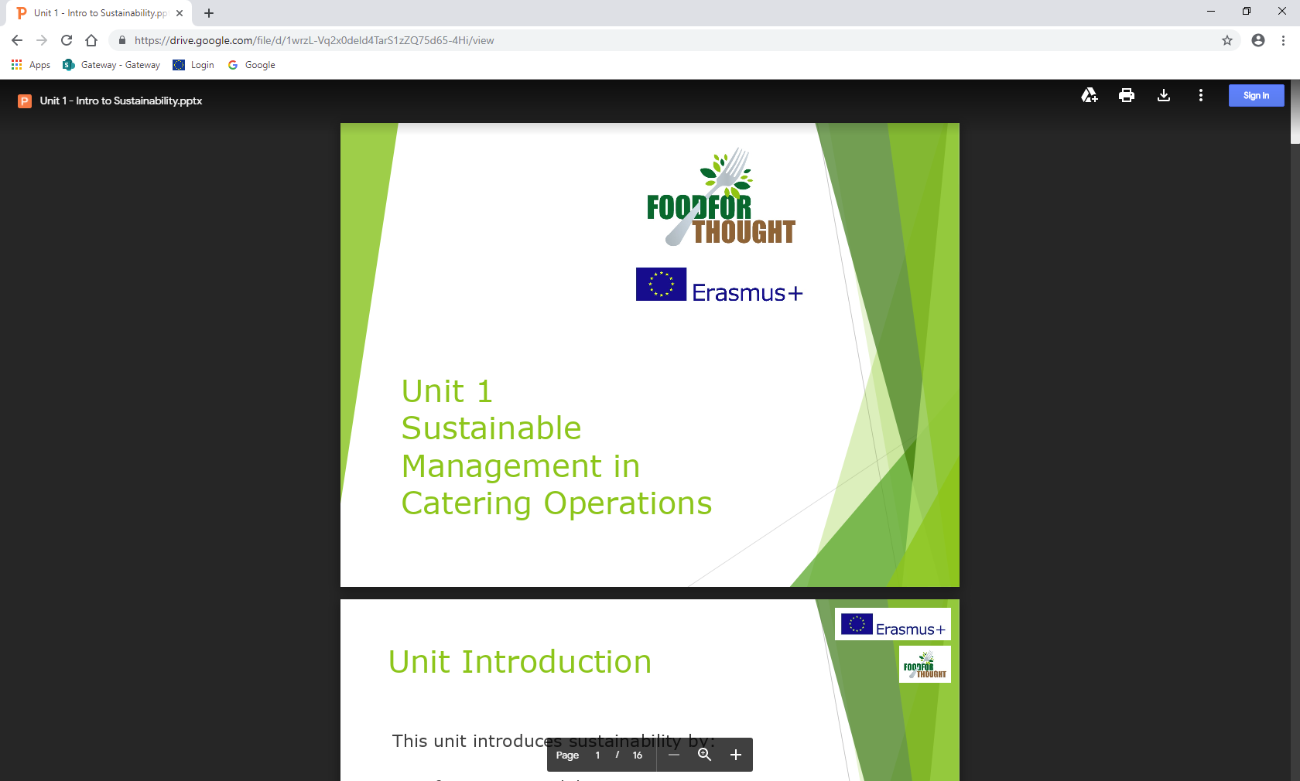

After the user has clicked on their chosen course document, it will open and display itself in an online format (shown above). The user can continue to view the document online or choose to download the material. The material can be saved for offline use or may be printed, as the user requires.